INSTRUCTIONS TO AUTHORS PREPARING THEIR CAMERA-READY PAPERS FOR JOURNAL FOR LETTER PAGE SIZE (Size 14)
First Author¹, Second Author², Third Author³ (Size 12)
¹Full address of first author, including country. (Size 9)
²Full address of second author, including country. (Size 9)
³Full address of third author, including country. (Size 9)

Received: Revised: Accepted: Published: (Size9)
Abstract: (Size 10) This document gives formatting instructions for authors preparing papers for publication in the Proceedings of an Journal. The authors must follow the instructions given in the document for the papers to be published. You can use this document as both an instruction set and as a template into which you can type your own text. The abstract must be written in the present tense and clearly state the novelty of the work regarding the journal fields. Ideally it will provide a brief context for the study, before describing the scientific approach and some key results in a qualitative manner. It should finish with a sentence to describe the implications for the field. The abstract must not include references, figures or tables. Do not use more than 250 words in the abstract, as it will be included in the on-line version of the journal and sent for indexing to international databases, in different formats. Very careful wording should be used in the title and in the abstract. Without a proper title and abstract, a great paper might never be downloaded and/or read.
Keywords: (Size 10) five keywords or phrases arranged alphabetically and separated by commas. A list of keywords may be found on the website. Use only the keywords defined there. [not capitalized (Except constant terms), plural, separated by commas, no full stop]

INTRODUCTION (SIZE 12 &BOLD)
The introduction should be succinct, with no subheadings. Limited figures may be included only if they are truly introductory, and contain no new results. (Size 10 & Normal)
Prospective authors are invited to submit papers that fit within the scope of the journal. Papers should be written in English and submitted in final camera-ready form. All text has to be edited by using the styles defined in this document.
It is mandatory to submit your original work in Microsoft Word format (.doc) or (.docx). We will do only minor corrections and the final formatting of your paper. (Size 10 & Normal)
FIRST-ORDER HEADING (SIZE 12 &BOLD)
SECOND-ORDER HEADING (SIZE 10 & BOLD)
THIRD-ORDER HEADING (SIZE 10 & BOLD & ITALIC)
Fourth-Order Heading (Size 10 & Normal & Italic)
MATERIALS AND METHODS (SIZE 12 &BOLD)
The materials and methods section should contain sufficient detail so that all procedures can be repeated. It may be divided into headed subsections if several methods are described. (Size 10 & Normal)
RESULTS AND DISCUSSION (SIZE 12 &BOLD)
The results and discussion may be presented separately, or in one combined section, and may optionally be divided into headed subsections. (Size 10 & Normal).
((Main Text Paragraphs. Please make the first reference to a display item bold (Figure 1). Do not abbreviate Figure, Equation, etc.; display items are always singular, i.e., Figure 1 and 2. Equations are always singular, i.e., Equation 1 and 2, and should be inserted using the Equation Editor, not as graphics, in the main text. Display items and captions should be inserted in-line within the main text)). ((References should be in the parenthesis and appear after punctuation. [1, 2]. [3–5] Footnotes should not be used in the text. Instead, additional information can be added to the Reference list.
Your paper must use a page size corresponding to Letter which is 8.5" wide and 11" long. The margins must be set as follows:
  - Top = Bottom = 1"
  - Left = Right = 1"
  - Header = Footer = 0.5"
The entire document should be in Times New Roman Font. Type other font types may be used if needed for special purposes.
TABLE 1. TITLE OF THE TABLE (SIZE 10 FOR THE TABLE CAPTION)
((TABLE CAPTIONS SHOULD BE PLACED ABOVE THE TABLES.))
(SIZE 10) | Table Header | Table Header
Heading | (SIZE 10) | Values
Heading | Values | Values
Heading | Values | Values
Source: Text follows (SIZE 10 Italic)
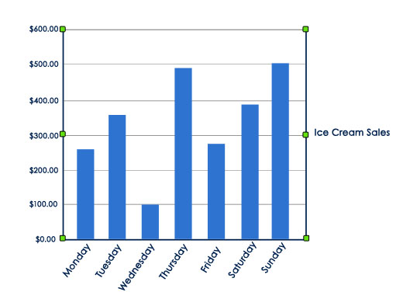
FIGURE 1. EXAMPLE FOR SMALL FIGURE (SIZE 10 FOR THE FIGURE CAPTION) ((FIGURE CAPTION NEED TO BE PLACED BELOW THE FIGURES. NOTE: PLEASE DO NOT COMBINE FIGURE AND CAPTION IN A TEXTBOX OR FRAME.))
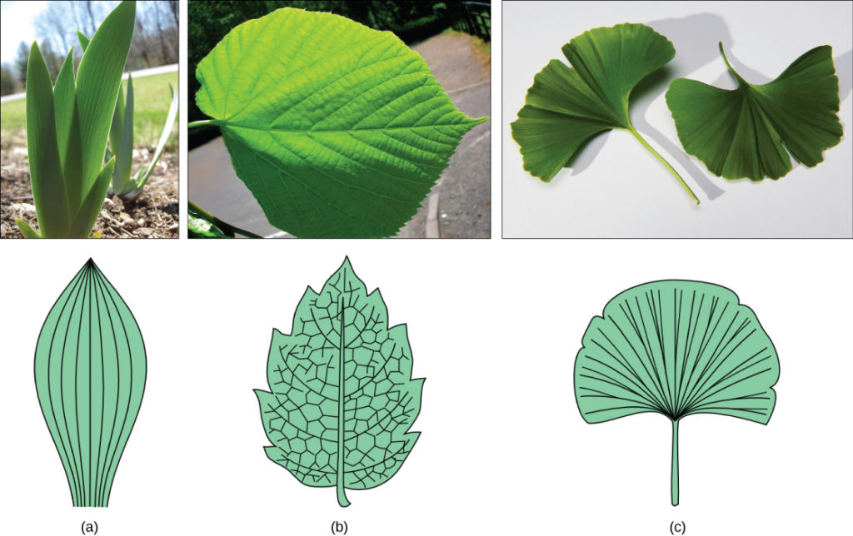
FIGURE 2. EXAMPLE FOR FIGURE CONSISTS OF MULTIPLE PANELS: REPRESENTATIONS OF SOME LEAFS. (A) TULIP, (B) LINDEN, AND (C) GINKGO BILOBA. (SIZE 10 FOR THE FIGURE CAPTION)

Figure must be positioned either at the top or at the bottom of the page. They should be referred to as (see Figure 1, etc.) in the main text. Please check all figures in your paper both on screen and on a black-and-white hardcopy. When you check your paper on a black-and-white hardcopy, please ensure that:
- The colors used in each figure contrast well,
- The image used in each figure is clear,
- All text labels in each figure are legible, &
- Reproduced with permission. [Ref.] Copyright Year, Publisher.
((Permission statement required for all figures reproduced or adapted from previously published articles/sources. CC-BY content can be used without asking permission, but the source must be attributed: Reproduced under terms of the CC-BY license. [ref] Copyright Year, The Authors, published by [Publisher]. However, permission must be obtained for reproduction of content published under CC-BY-NC/ND/SA licenses; delete if not applicable.))
If a figure consists of multiple panels, they should be ordered logically and labelled with lower case roman letters (i.e., a, b, c, etc.). If it is necessary to mark individual features within a panel, this may be done with lowercase Roman numerals, i, ii, iii, iv, etc. All labels should be explained in the caption. Panels should not be contained within boxes unless strictly necessary. (See Figure 2)
EQUATIONS
Equations and formulae should be typed in equation plug-in like Microsoft Word’s equation tool, and numbered consecutively with Arabic numerals in parentheses on the right-hand side of the page (if referred to explicitly in the text). They should also be separated from the surrounding text by one space. They should be referred to as Equation 1, etc. in the main text.
A + B x C / (D - E) = F (1)
Displayed equations are centered and set on a separate line. Please avoid rasterized images for equations, tables, flow charts, algorithms, datasets, line-art diagrams and schemas. Whenever possible, use vector graphics instead.
CONCLUSION (SIZE 12 &BOLD)
The Conclusions section should clearly explain the main findings and implications of the work, highlighting its importance and relevance. (SIZE 10)
REFERENCES (FONT SIZE 12 & BOLD)
Note: Authors should ensure that their citations are accurate; Authors should not cite sources that they have not read; & Authors should not preferentially cite their own or their friends’, peers’, or institution’s publications.
(Authors are requested to follow the below reference format in a strict manner)
Examples of reference items of different categories shown in the References section include:
- (Font Size 10, Line Spacing 1.15) Souraya Hamida, and Okba Kazar, “New Mobile Cloud Computing Approach Based Multi-Agent System for OWL-S Services,” International Journal of Engineering Research in Africa, vol. 60, no. 1, pp. 173–187, 2022. [CrossRef] (For Journal)
- A. Cerino and W. P. Walsh, “Research and Application of Radio Frequency Identification (RFID) Technology to Enhance Aviation Security,” Proceedings of the IEEE 2000 National Aerospace and Electronics Conference. NAECON 2000, USA, pp. 127-135, 2000. [CrossRef] (For Conference)
- Jonathan Wickert, and Kemper Lewis, An Introduction to Mechanical Engineering, 3rd ed., Change Learning Publisher, 2006. (for Book)
- The IEEE Website, Browse Journals & Magazines, 2024. [Online]. Available: https://ieeexplore.ieee.org/browse/periodicals/title (For Website)
- K. Asokan, “A Study on Stress Level among Medical Practitioners with Special Reference to NABH Accredited Hospitals in Chennai,” Ph.D. Thesis, Dr. M.G.R. Educational and Research Institute, Chennai, India, 2021. (for Thesis)

